1. 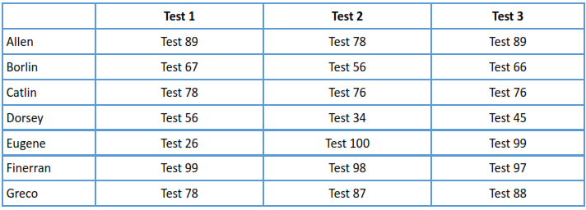You should form a table on a worksheet titled “class list” that includes the names and test scores of your students. You have 7 students in your class, their names are: Allen, Borlin, Catlin,Dorsey, Eugene, Finneran, and Greco. Their scores on the first 3 tests are as follows:
   1. Below your table, create a graph showing the students’ rounded averages. Be sure to include appropriate labeling and spacing, so that the graph is non-repetitive and the scale is appropriate. Hint: A score of 100 is the highest possible.

**Answer:**



* 1. Insert a new worksheet. Use the Goal Seek feature to find the value that Eugene needed on Test 1 in order to earn honors for the course. Show your work by displaying an updated table. Title the worksheet “Eugene’s dream.” Hint: Do not worry about rounding Eugene’s new “score” for Test 1. If done properly, the rest of your table should update accordingly.

**Answer: Eugene needs to score 86.4 in the 1st test to get an honors**



* 1. From the data on your “class list” worksheet, provide the Descriptive Statistics of your students’ rounded averages. For the output, create a new worksheet and choose to display “summary statistics”. Rename this worksheet “Descriptive Statistics”.

**Answer:**

